**LIBRARY MANAGEMENT SYSTEM** Simplified Book Record Management

**Prepared By :**

**Muhammad Mustafa(21MDBCS121)**

**Usama Sardar(21MDBSC126)**

**Shaheer Khan(21MDBCS119)**

**What is a Library Management System?**

* **A software application designed to manage library functions/records such as adding, issuing, and returning books.**
* **Helps streamline record-keeping.**
* **Its actually for that person who is responsible for managing library data..**

**Key Functions of the System**

* **Add new books to the library catalog.**

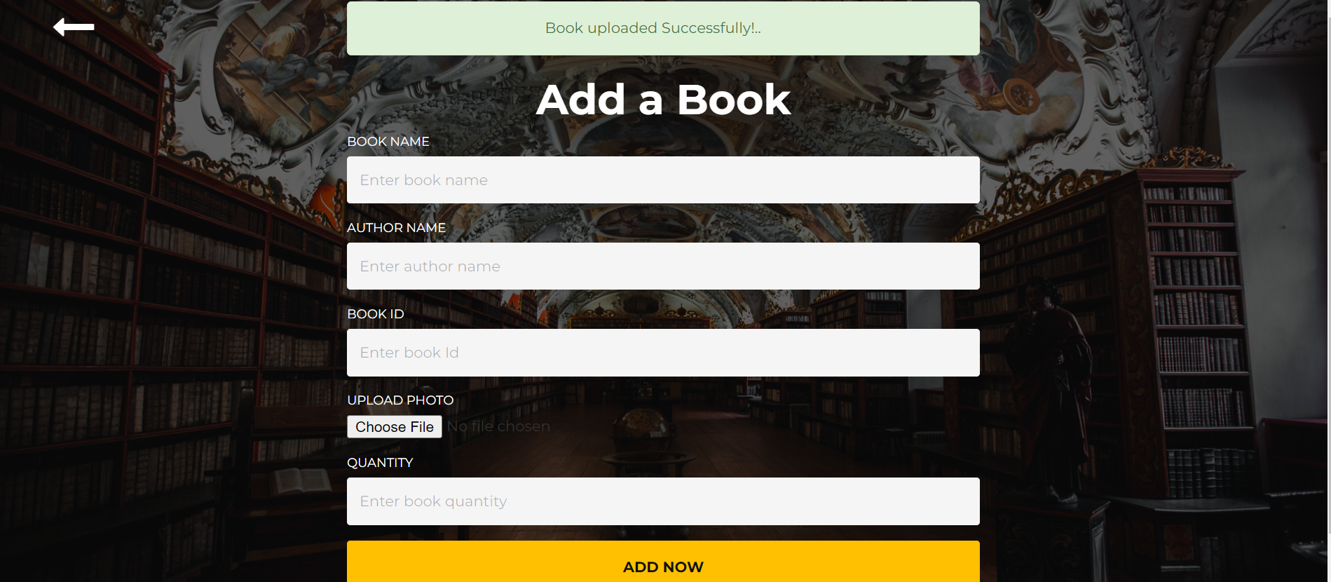

* **Issue books to members.**

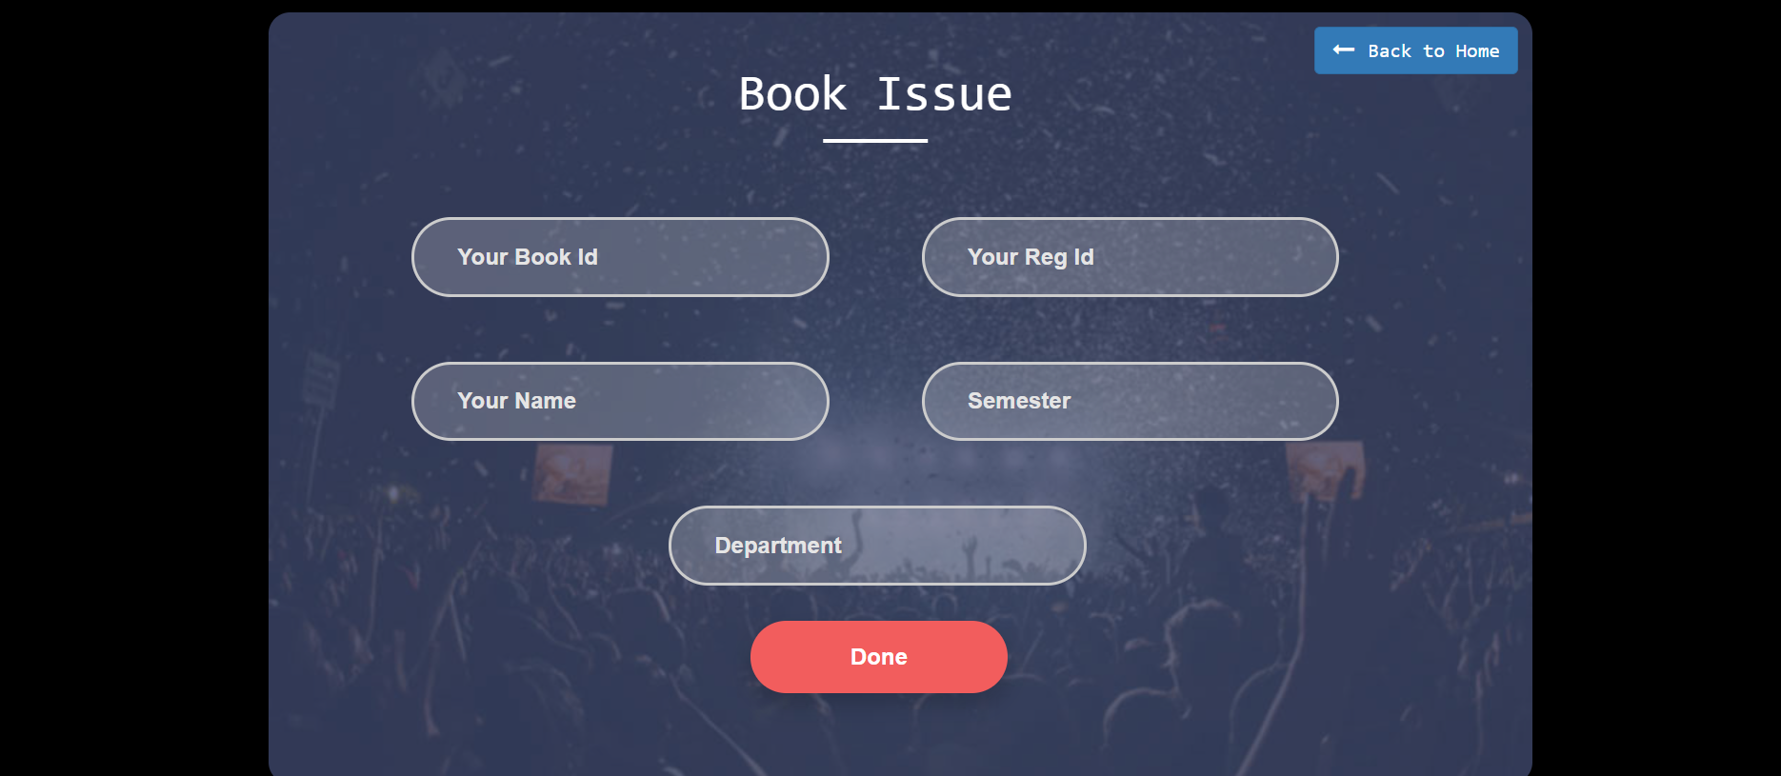

* **Keep records of issued books.**

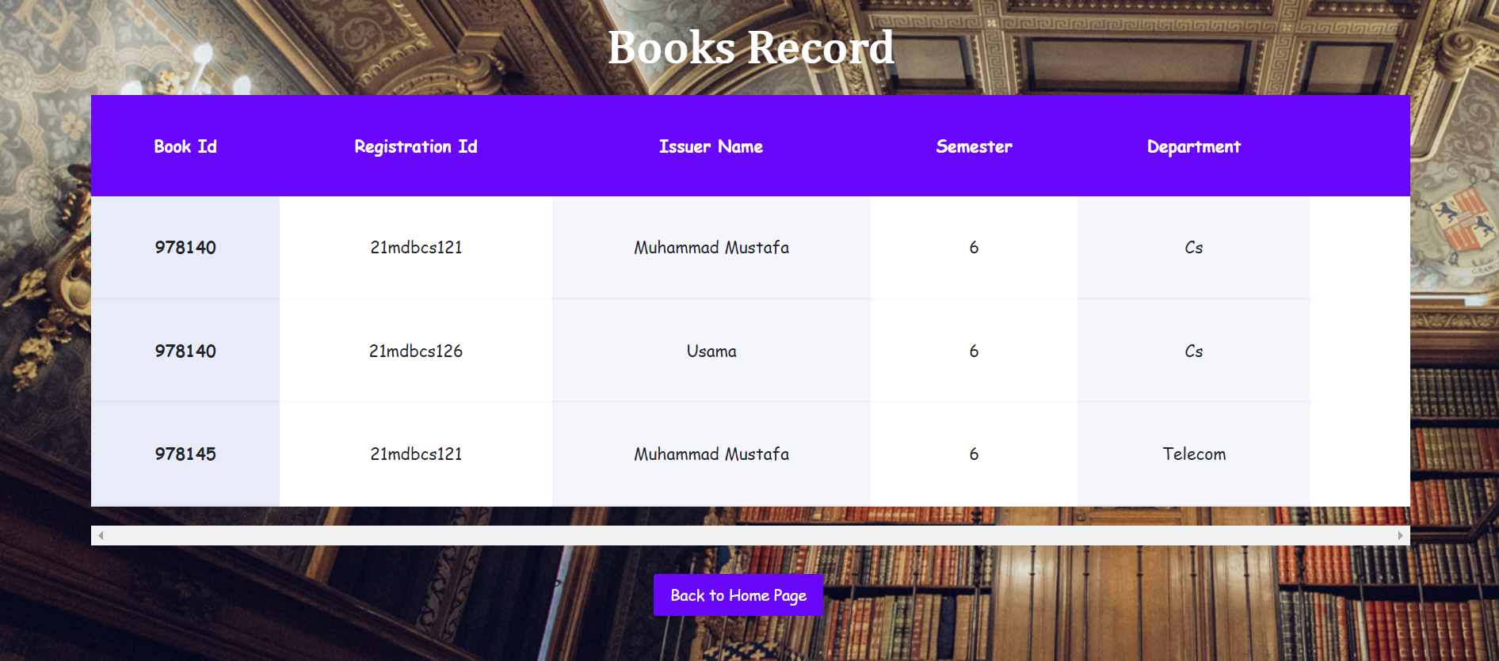

* **Process book returns and update records.**

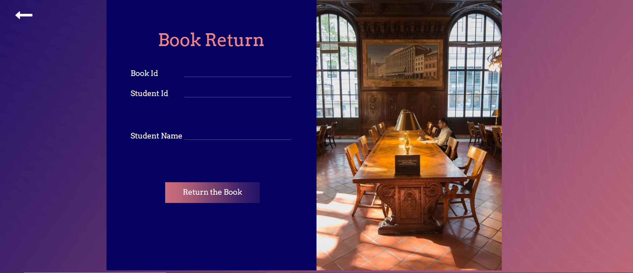

* **Search a book .**

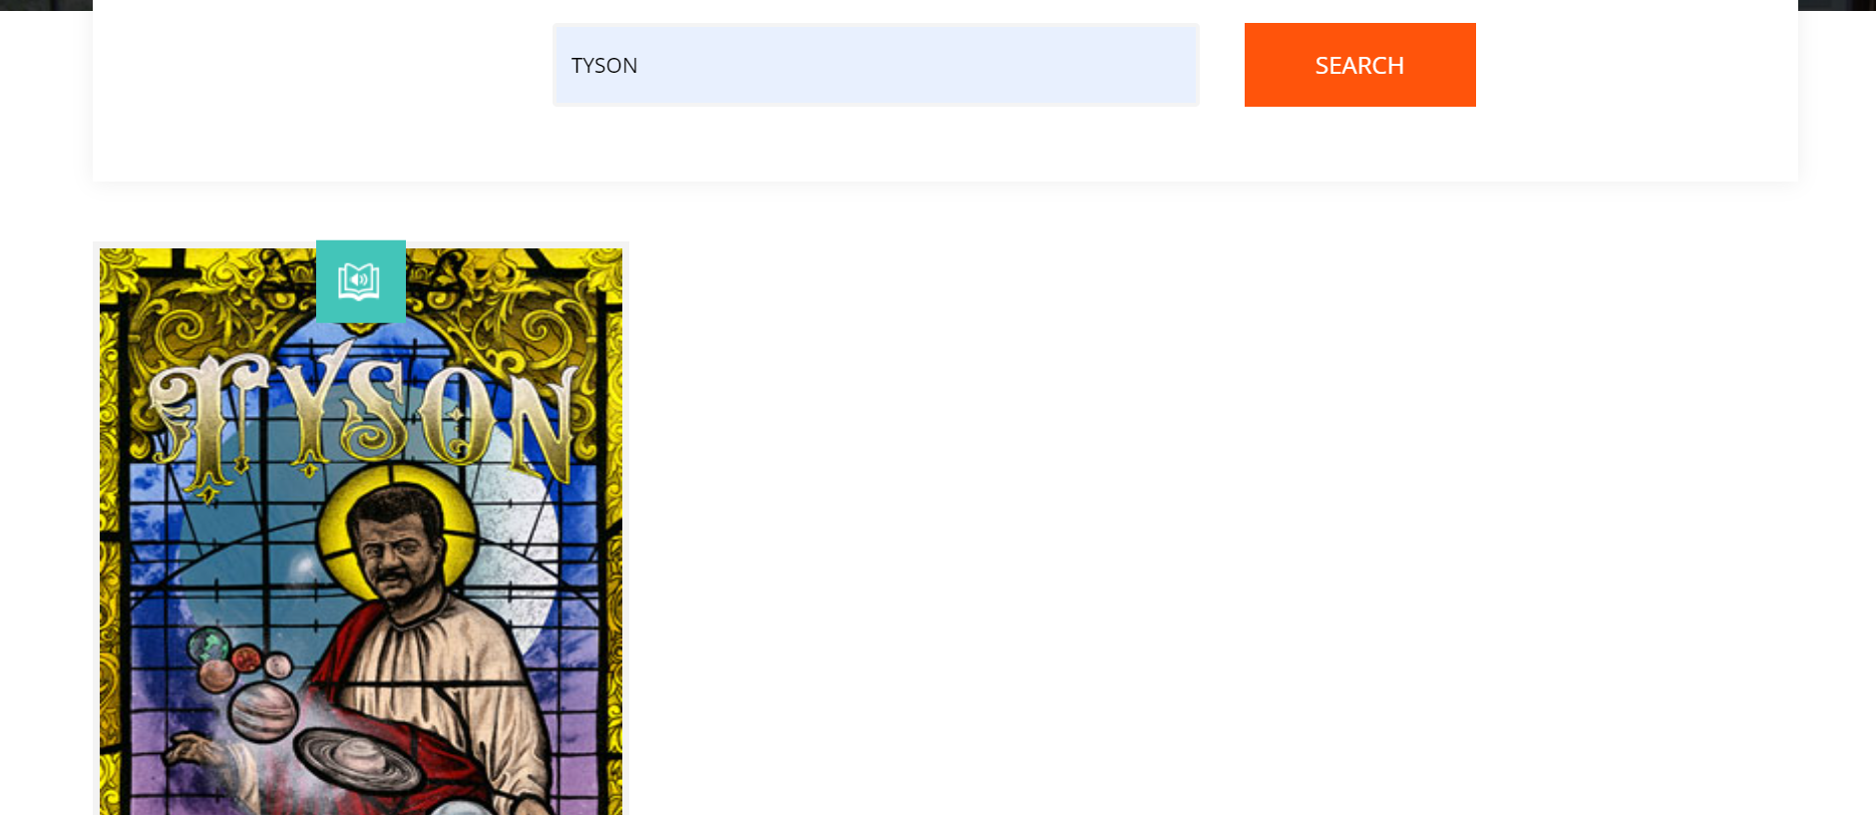

**Benefits of this system**

* **Saves Time: Automates tasks like adding, issuing, and returning books.**
* **Reduces Errors: Minimizes mistakes with automated data entry.**
* **Secure: Protects data with restricted access and backups.**
* **Cost-Effective: Cuts down on paperwork etc.**

**Database:**

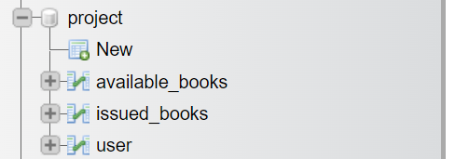

**Available books table :**

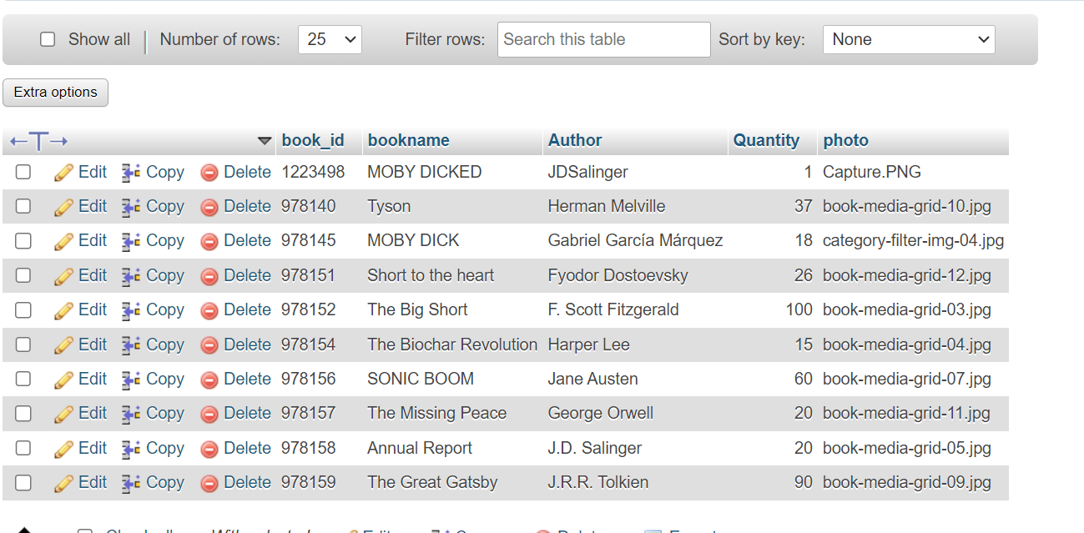

**Issued books table :**

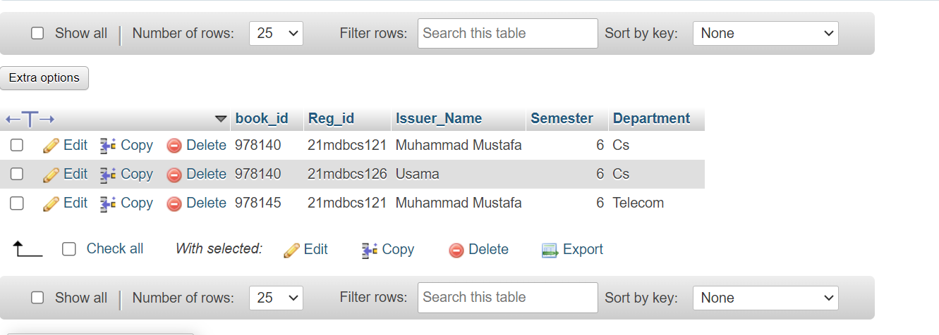

**User table :**  
